**Prepared By:**

**1-Yahya Mohamed Mansour Hassan hamza** **sec:9 CS**

**2-Mohamed sabry mahmoud shehab eldean sec:6 CS**

**3-Eslam Hany Elsayed Nabwy Zoghla sec:2 CS**

**4-Hadi Rabee Kamel Alam sec:9 CS**

**5-Adham Ashraf Ebrahim Elganzoury sec:1 CS**

**6-Alaa abdelmaksod Mohamed zahra sec:2 CS**

**Web Programming**

**Project**

**Instructor: DR Mostafa Elgendy**

**Abstract**

Nowadays, most people have many problems in the life, the most popular cause of this problems is the lack of money, A lot of people has not enough money to have a happy life and you may find that they can't spend enough time with their family and friends cause of taking much time in their work and this make them unhappy in their life.

What if there were a way to gain a lot of money ?

What if there were a way to get rid of these problems mentioned?

I can tell you that you can do this from your home throw our website. This is so amazing ,isn't that?

Our specialized experiences have built a great website can help you overcome these problems and lead you to a happy life .

Our website will help you find suitable work quickly and offers you a lot of freedom and flexibility so that you can gain more and more money in addition to have no problems of spending enough time with your friends and family which regular jobs can't.

As you can choose the type of the work, time of the day to work, how long you work, a location to work and volume of work you take on.

In our website you can find many services distinguish with flexibility also that helps you complete your job in a fast time and with good cost.

become a self-employee, control your work relationship, and control workload. In addition to gain more and more money.

All of what you should do is to register to our website.

Feel free to do so.

**Introduction**

Freelancing is a contract-based profession where you use your skills, education, and experience to work with many clients and take on different tasks. Freelancing usually includes jobs that allow you to work from home. It is just that many of the jobs performed by freelancers can be delivered online without being in the company's or client's place to increase income and avoid any disasters in the world such as the coronavirus that turned the world upside down.

Winton website acts as a link between the freelancer and the client and facilitates communication between them, and it is easy to use and helps the client to follow up on the previous work of the freelancer, and if he sees that he meets his needs, he begins to communicate with him, or the client writes a publication with all his needs and determines the time and the required price, and the freelancers begin to communicate with him.

One of the most important advantages of Winton instead of working for one full-time employer and getting a fixed salary in return, he has many clients according to his terms and price, because he believes that his work is worthy.

Once the freelancer has determined the services they will provide, Winton allows them to share a collection of previous works, depending on their own skill, so that customers begin to communicate with him to implement their need and as the beauty of his work increases, more projects will come to him, for example, in terms of designing independent drawings, this may come in the form of images you have developed, and perhaps some pieces of art, as well as samples of previous works.

**Description**

This site is a marketplace there exist a three type of person, person need a service and person who do this service and admin to monitor and administrate this website ,add person to this website. any person can find services in different prices. This site provide a convenient way for freelancers to find work and for employers to find qualified professionals to complete their projects ,all member in this site can post works and jobs to be shown on the site according to the member field .then they can see all requests on their posts, person has a features to delete reply or posts of him and posts of person exist on personal page according to latest posts ,any person can see posts at the same field and can go to personal page of this person and see old posts

this website has Many advantages such as:

* This website is a free to login and make account in it.
* Empoyers can find services easly with different prices .
* If employers find their service can contact with person that do this service easily .
* Save time that you search to find service.

There exist many pages or frames in this site

* Index Page
* Register page
* Sign in page
* Main page
* Personal portfolio
* Portfolio view

**Services**

- Presenting the user's file (his posts, method of dealing, and previous work) to customers to facilitate communication between the worker and the customer.

- Facilitates the interaction between the worker and the customer (transferring information about the required project, receiving payment after receiving the project, receiving the customer's evaluation after receiving it)

- Helps the client to know the employee by presenting his previous work and evaluating it from his previous clients and his way of dealing.

- It helps its users to receive work from home, working from home is more comfortable for many people. Employees can save a great deal of time and money because they do not have to travel as much, which means that people will have more time for work and for themselves as well. People can choose to work in their garden or backyard, anywhere that makes them comfortable to work. Moreover, employees are under less stress because they decide when to work and when to take a break. These things will help in giving better performance of the tasks.

**Index Page**

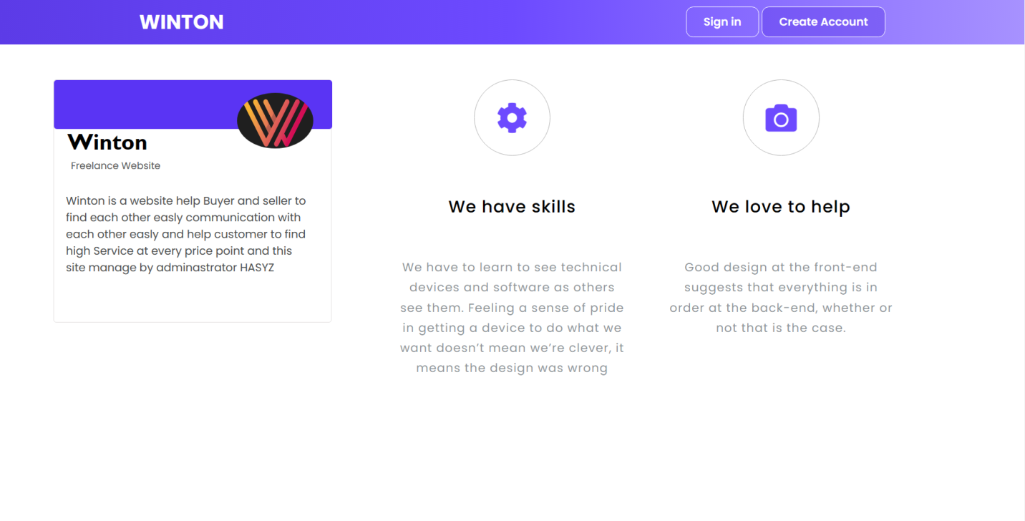

This is index page or first page that shown to any person enter or open this

website and can know quick informations about website and determine If

he enter to the system via sign in if he has account on system or create

account. this page has information about persons programming this

website and our contacts if any person needed to contact with us.

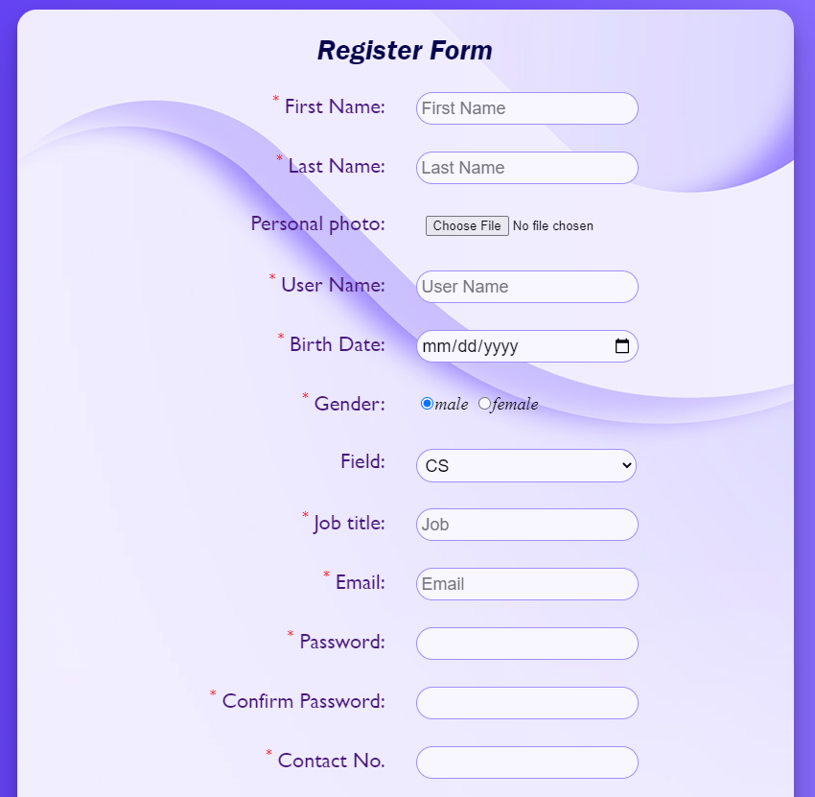 **Register Page**

Register form

This page is used to collect all data about user and save it to database

There are required field that appears with red star in previse photo (*) which user must entered, all this value is unique can’t be duplicated to 2 users

When user click Register button,

System checks all this data if any of this data already founded in database, show message error with duplicated data and user must change it to register successfully.

**Sign in page**

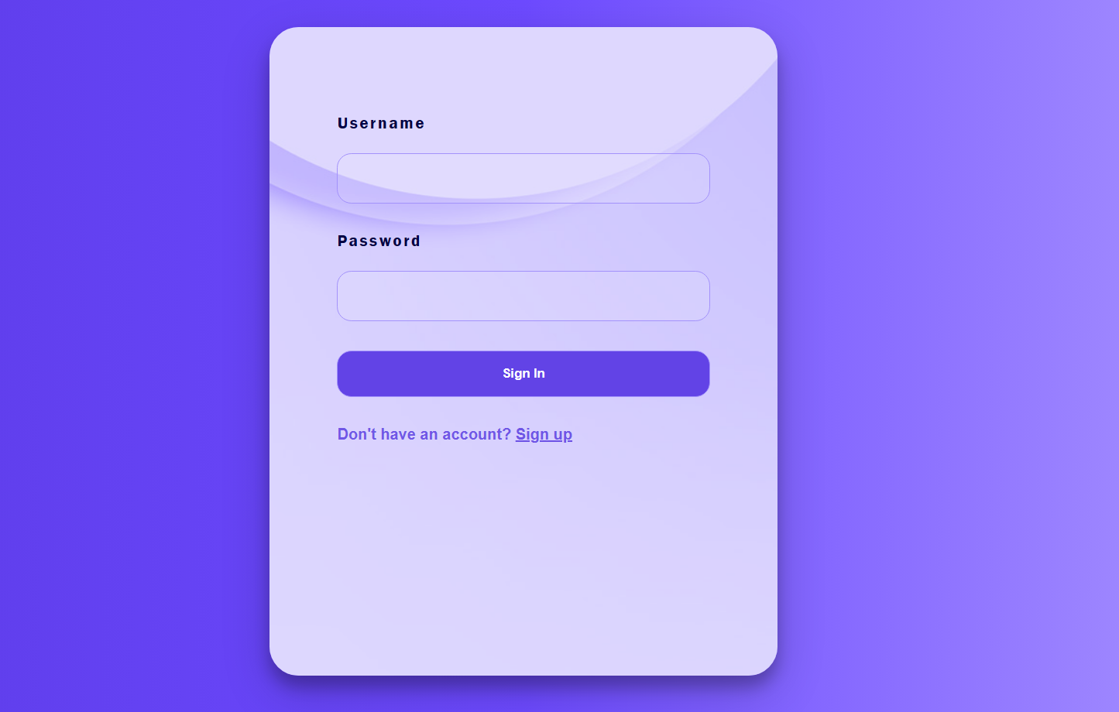

Sign in page this page was shown when user want to login the system and click

On sign in button in the index page ,user enter username and password

And click on sign in ,if username and password are true user login to the

System successfully.

**Main Page**

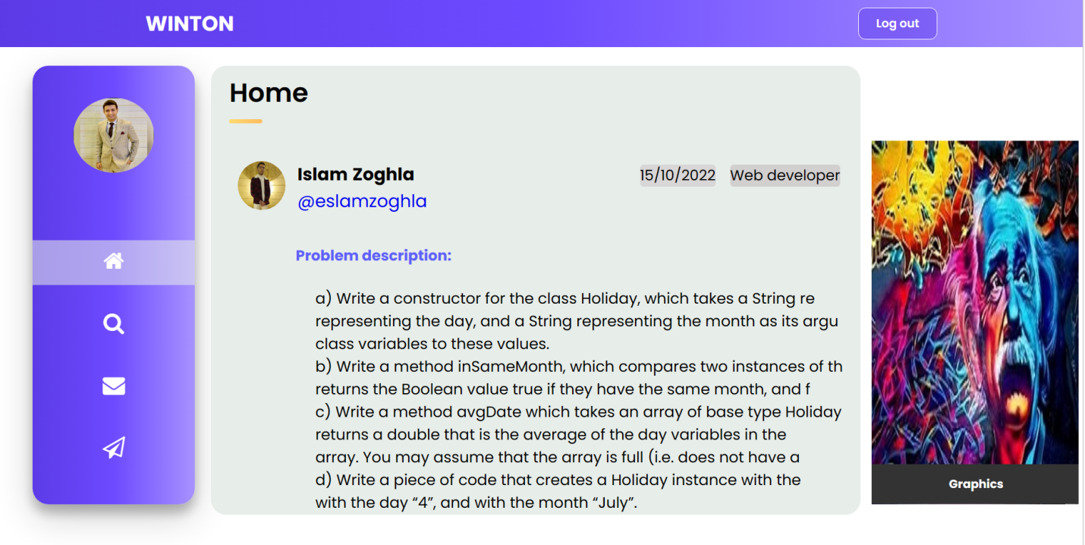

This is main page in this page exist all posts that are published not all posts but posts have the same field that you have determined to see, on each post exist date of post ,field , username of publisher ,problem description that describe problem that publisher want to solve it ,problem instruction to person who can solve this problem, price of this problem that person take when solve this problem and period that publisher want from employee to solve this problem, any employee can solve this problem can send request to publisher.

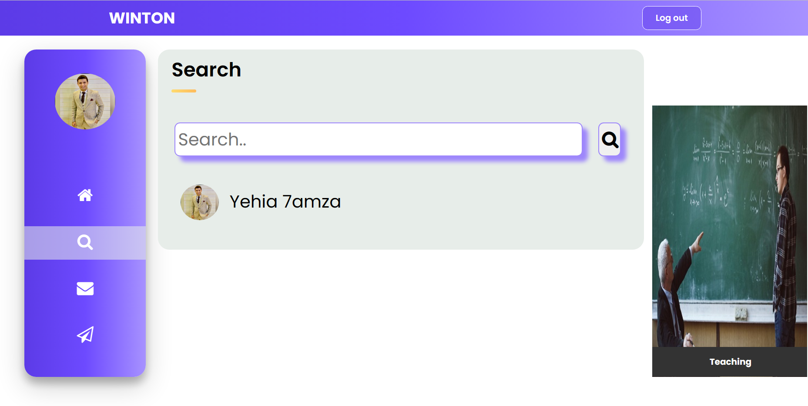

When you click on this icon you can search about any username of member that

have the same word you enter in this entry and you can go to any personal

page that have the same username when you click on it and see all old

posts and all information about this person.

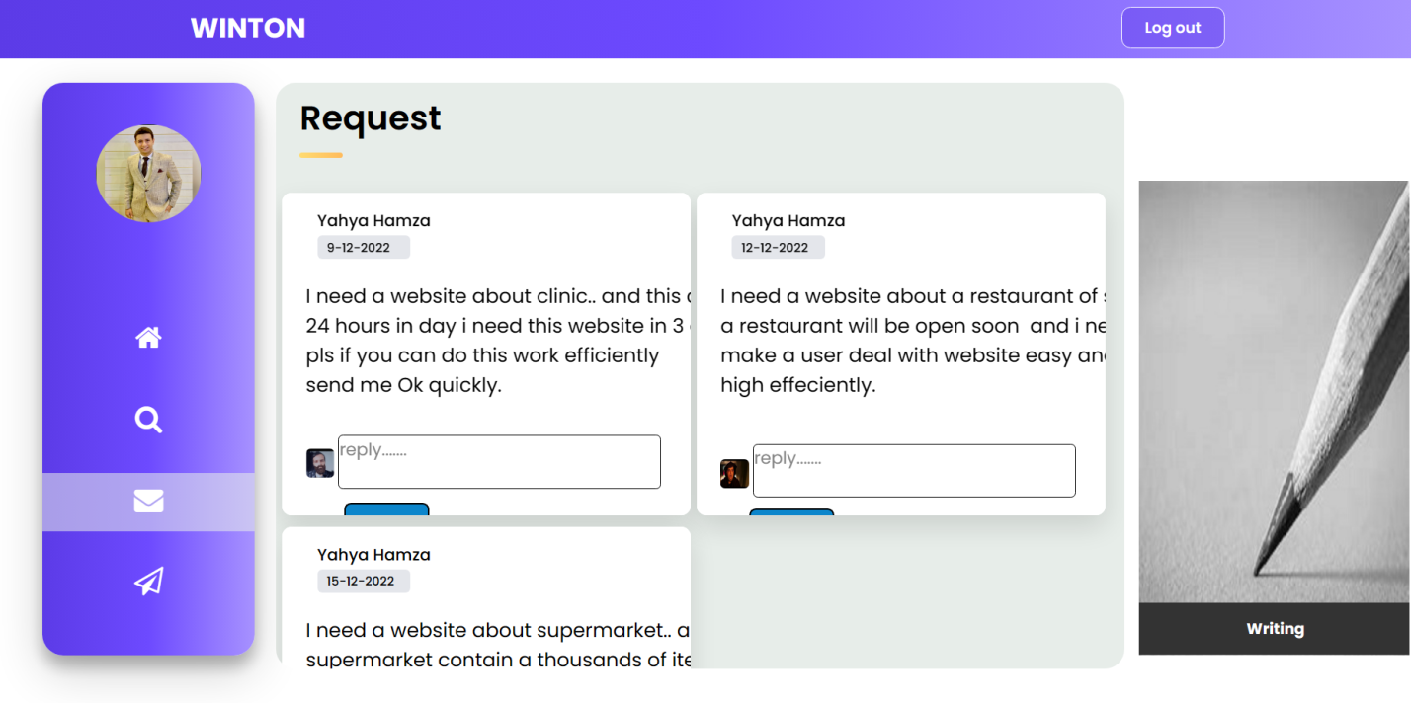

When you click on this icon you see all requests on your posts ,date of your

Posts and each reply from another peoble with them photes and you can

Go to personal page of this person and see all information about this

Person , see old posts then detemine if you accept this person and let

him to solve your problrm or not and you can delete this request via

click on delete button.

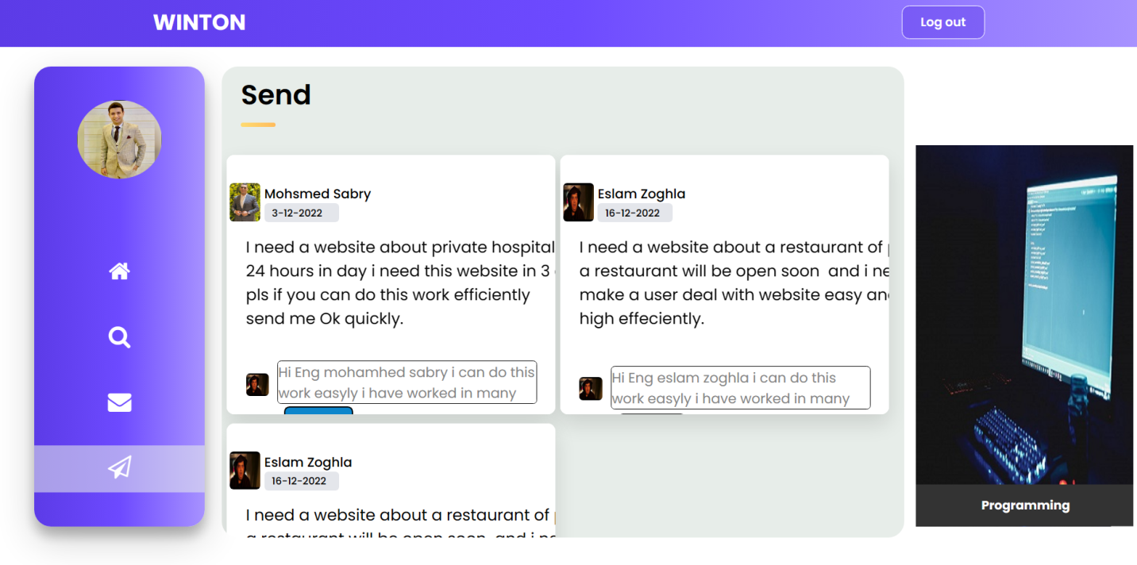

When you click on this icon you can see your replies on other posts,

Date of this posts and who publish this post, you can go to personal page

of this person when you click on image of him and you can delete your

replies on this post when you click on delete button.

**Personal portfolio**

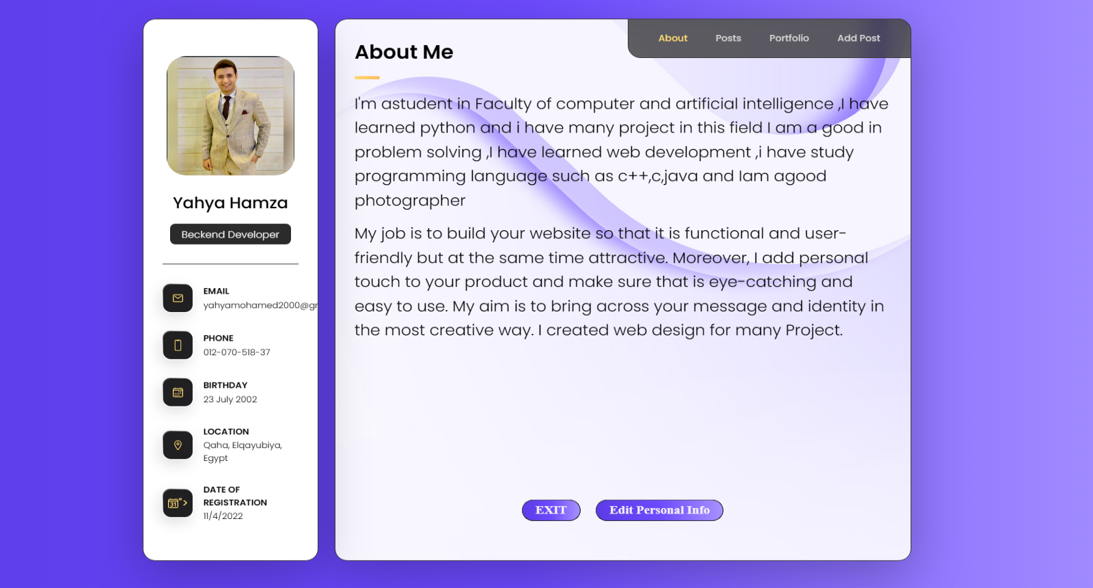

This is a personal portfolio of you that show all information about you(email

,phone, birthday , location , date of regasteration ) and about button on

navigation bar show quick information ,interests and job of you.

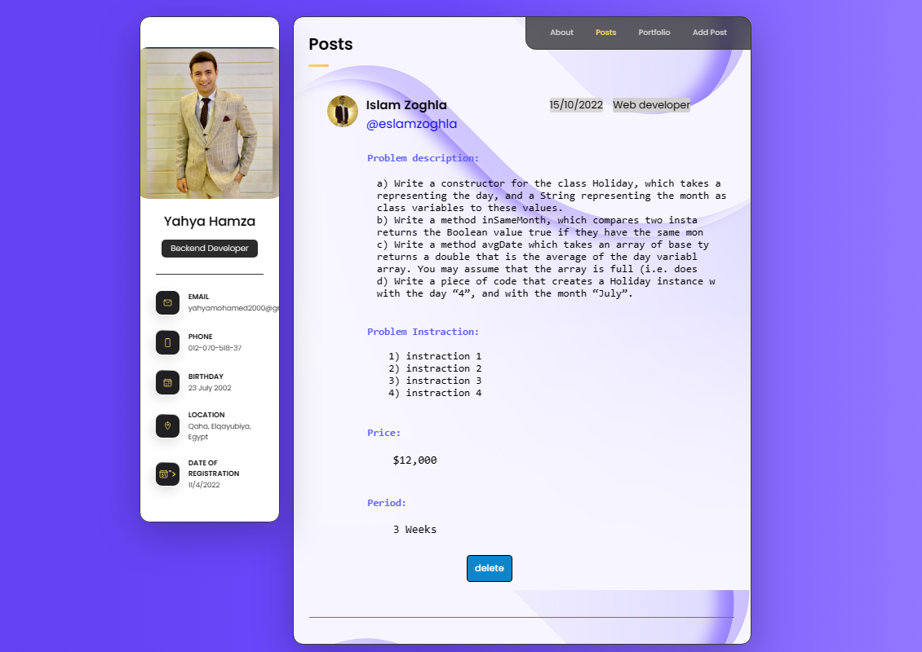

When you click on button posts you see all posts that you published (date

of post-problem description-problem instruction-price-period-field of post)

and you can delete this post when you click on button delete.

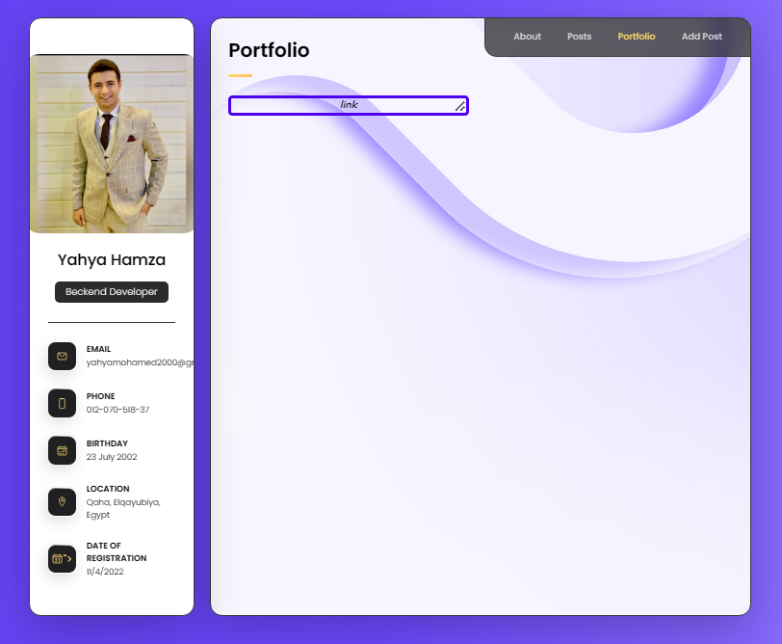

When you click on portfolio on navigation bar see link, this link lead to your

projects when you click on it.

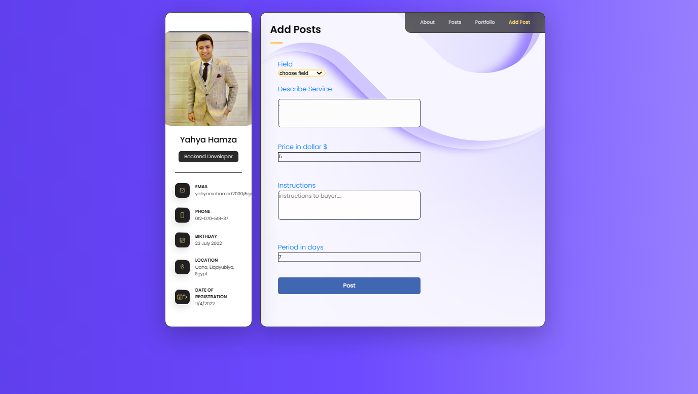

When you click on add post on navigation bar you can add post throw

You determine field of your post ,describe your service,price of this service

That you will pay to person who solve this problem ,instructions to person

That solve this problems, period that you want from person to solve this

problem and click on button post then this post published and will show

on main page.

**Portfolio view**

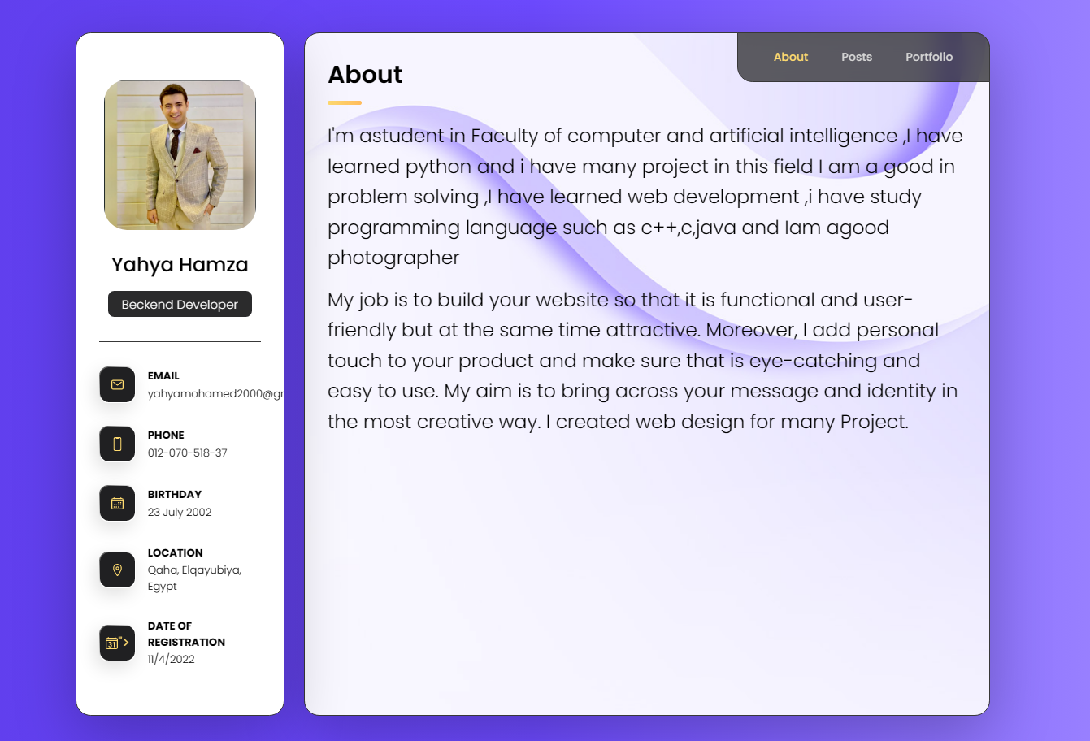

This is a personal portfolio other people, see all information about

person(email ,phone, birthday , location , date of regasteration )

when you click on about button On navigation bar show quick information

,interests and job of person

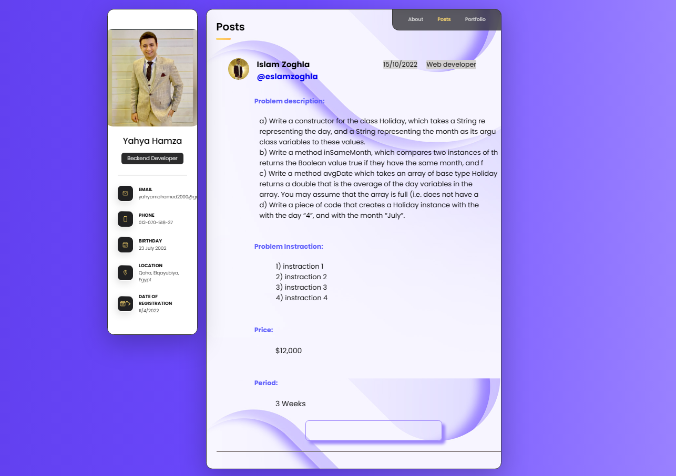

When you click on button posts you see all posts that person published

(date of post-problem description-problem instruction-price-period-field of

post)and you can reply on this post when you click on entery and send it to person.

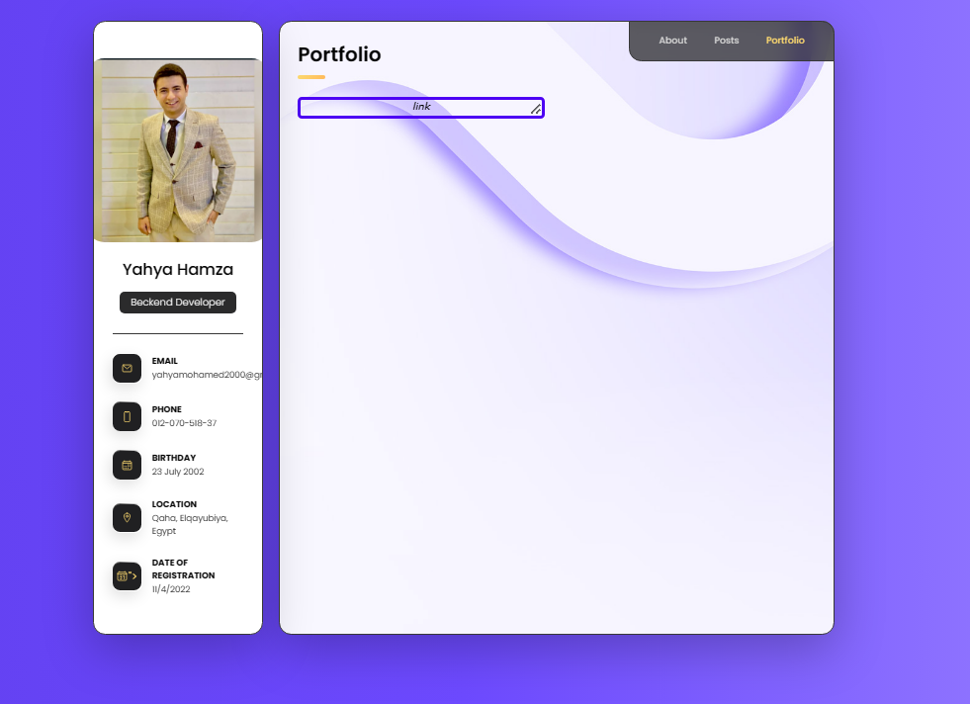

When you click on portfolio on navigation bar see link, this link lead to

Projects of person when you click on it.

**Entity Relationship Diagram (ERD)**

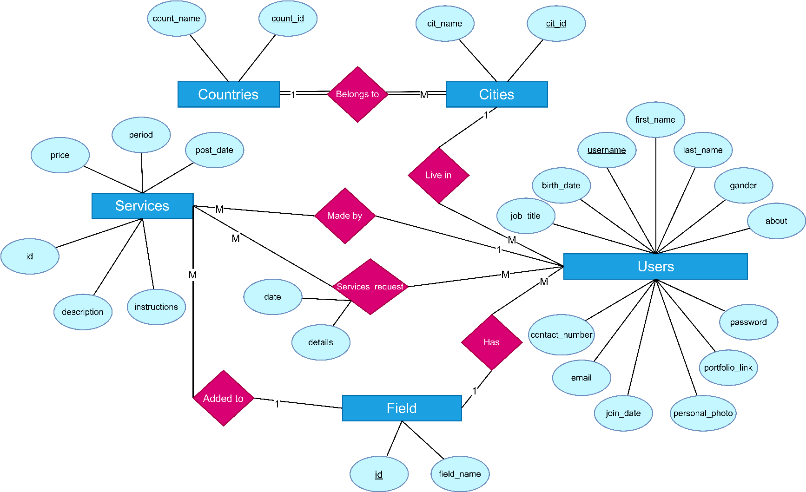

**Mapping**

